

Project Report
Deep Learning (CT- 468)

Smart Fraud Detection in Banking Transactions

DT-22002 Neha Laeeq
DT-22043 Talal Khan
DT-22041 Ahmed Hassan
DT-22037 Shayan

Index
Abstract 3
1. Introduction 4
1.1 Background 4
1.2 Problem Statement 4
1.3 Project Objectives 4
2. Literature Review & Methodology Justification 4
2.1. The Shift from Rule-Based to Unsupervised Anomaly Detection 4
2.2. Gradient Boosting for Imbalanced Classification 5
2.3. The Power of Hybrid Ensembles (The "Two-Stage" Approach) 5
3. Methodology 6
3.1 Dataset Description 6
3.2 Data Preprocessing 6
3.3 Model Architecture 6
Stage 1: Autoencoder (Unsupervised) 6
Stage 2: XGBoost Classifier (Supervised) 6
4. System Analysis and Architecture 7
4.1 High-Level Architecture 7
4.2 Data Flow 7
5. Implementation Details 8
5.1 Technology Stack 8
5.2 Training Optimization 8
6. Results and Evaluation 8
6.1 Evaluation Metrics 8
6.2 Performance Analysis 8
7. Conclusion and Future Work 9
7.1 Conclusion 9
7.2 Future Enhancements 9
8. References 10

Abstract
Credit card fraud represents a significant financial risk to banking institutions and consumers worldwide. Traditional detection methods often struggle with the dynamic nature of fraud and the severe class imbalance inherent in transaction datasets, where fraudulent activities constitute a minute fraction of total traffic. This project presents the Smart Fraud Detection System, a real-time anomaly detection framework that leverages a hybrid ensemble learning approach. The methodology combines a Deep Autoencoder (unsupervised learning) to model normal transaction patterns and generate reconstruction error features, with an XGBoost classifier (supervised learning) to perform the final binary classification. By augmenting the feature space with anomaly scores derived from the Autoencoder, the system effectively captures both pattern-based and anomaly-based fraud signals. The system is implemented using a microservices architecture with FastAPI and PostgreSQL, ensuring scalability and real-time inference capabilities. This report details the system architecture, machine learning methodology, implementation strategies, and evaluation metrics, demonstrating a robust solution for minimizing false negatives in high-stakes financial environments.

1. Introduction

1.1 Background
With the exponential growth of digital banking, online financial fraud has evolved into a sophisticated criminal enterprise. Financial institutions process millions of transactions daily, making manual review impossible. Automated detection systems are essential, yet they face significant challenges: legitimate transactions vastly outnumber fraudulent ones (class imbalance), and fraud patterns change rapidly (concept drift).

1.2 Problem Statement
Existing rule-based systems or simple linear classifiers often yield high False Negative rates (missing actual fraud) or high False Positive rates (blocking legitimate users). Furthermore, standard supervised learning models struggle when trained on highly imbalanced datasets, often biasing predictions toward the majority class.

1.3 Project Objectives
The primary objectives of this project are:
- Develop a Hybrid Model: To construct a two-stage ensemble model combining deep learning (Autoencoder) and gradient boosting (XGBoost).
- Handle Class Imbalance: To implement techniques such as reconstruction error augmentation and weighted loss functions to address the <0.2% fraud rate.
- Real-Time Deployment: To engineer a production-ready pipeline using FastAPI that can process transactions and serve predictions in real-time.
- Visualization: To provide a dashboard for monitoring transaction logs and anomaly alerts.

2. Literature Review & Methodology Justification
The design of the Smart Fraud Detection System is grounded in recent advancements in computational finance and anomaly detection. A review of current literature highlights three critical pillars that justify the chosen ensemble architecture: the efficacy of reconstruction-based anomaly detection, the robustness of gradient boosting on tabular data, and the superior performance of hybrid architectures in high-imbalance scenarios.

2.1. The Shift from Rule-Based to Unsupervised Anomaly Detection
Traditional fraud detection relied heavily on static rule-based engines (e.g., "if amount > $10,000, flag"). However, research indicates these systems fail to capture non-linear and evolving fraud patterns ("concept drift").
- Why Autoencoders? Deep Autoencoders (DAEs) have emerged as a dominant unsupervised method for financial anomaly detection. As demonstrated in studies by Abbasimehr & Fanai (2022) and Sakurada & Yairi (2014), Autoencoders leverage the "Reconstruction Error Hypothesis." By training a neural network exclusively on normal transactions, the model learns the latent manifold of legitimate behavior.
When a fraudulent transaction (an anomaly) is fed into this trained network, the model fails to reconstruct it accurately, resulting in a high Mean Squared Error (MSE). This MSE acts as a powerful, self-learned "anomaly score" feature, capable of flagging novel fraud attacks that supervised models might miss because they haven't seen that specific pattern before.

2.2. Gradient Boosting for Imbalanced Classification
While deep learning excels at feature extraction, tree-based ensemble methods often outperform neural networks on structured (tabular) data.
- Why XGBoost? Chen & Guestrin (2016) introduced XGBoost (Extreme Gradient Boosting), which has become the industry standard for fraud classification. Its superiority is cited in numerous comparative studies (e.g., Dhankhad et al., 2018) for two key reasons:
  - Handling Class Imbalance: Unlike standard logistic regression, XGBoost supports weighted loss functions (scale_pos_weight), allowing it to penalize false negatives more heavily—a critical requirement when fraud constitutes less than 1% of data.
  - Sparsity Awareness: It efficiently handles sparse data inputs, which is common in high-dimensional financial datasets (like the PCA-transformed V1-V28 features).

2.3. The Power of Hybrid Ensembles (The "Two-Stage" Approach)
The most compelling justification for this project's architecture comes from recent literature advocating for Hybrid Learning.
- Why Combine Them? A single model often trades off between Precision and Recall.
  - Autoencoders have high Recall (catch many anomalies) but low Precision (many false alarms).
  - XGBoost has high precision but may miss novel fraud types (low Recall for unseen patterns).
- Recent research by Prabha & Priscilla (2024) and Abbasimehr (2023) demonstrates that feeding the reconstruction error from an Autoencoder as an additional feature into XGBoost creates a "super-learner." The XGBoost classifier learns to trust the Autoencoder's "suspicion" (high error) while using its own decision trees to filter out false alarms based on other feature interactions. This hybrid approach has been empirically shown to improve F1-Scores significantly compared to using either model in isolation.

3. Methodology

3.1 Dataset Description
The system utilizes a credit card transaction dataset containing 28 PCA-transformed features (V1-V28), time, and transaction amount.
- Total Features used: 29 (V1-V28 + Amount).
- Class Label: 0 (Normal), 1 (Fraud).
- Imbalance Ratio: Fraud accounts for approximately 0.17% of the data.

3.2 Data Preprocessing
- Feature Selection: The 'Time' variable is discarded as it does not contribute to intrinsic transaction characteristics.
- Scaling: All inputs are normalized using StandardScaler to achieve a mean of 0 and a standard deviation of 1. This is critical for the convergence of the neural network.
- Splitting: Data is split into training (80%) and testing (20%) sets, preserving the class distribution.

3.3 Model Architecture

Stage 1: Autoencoder (Unsupervised)
The Autoencoder is a symmetric neural network trained only on normal transactions.
- Input Layer: 29 Neurons.
- Encoder: Compresses input through dense layers (32 $→$16$→$ 8 $→$ 4).
- Bottleneck: A latent vector of size 4 forces the model to learn the most salient features of legitimate data.
- Decoder: Reconstructs the input (4 $→$ 8 $→$ 16 $→$ 32 $→$ 29).
- Loss Function: Mean Squared Error (MSE).
- Output: The Reconstruction Error, calculated as:
$MSE = \frac{1}{n} \sum_{i = 1}^{n}{}{{(x_{i}-\hat{x}}_{i})}^{2}$

Stage 2: XGBoost Classifier (Supervised)
The classifier is trained on the entire dataset (Normal + Fraud).
- Input Features: Original 29 features + Reconstruction Error (from Stage 1).
- Algorithm: Gradient Boosting Decision Trees.
- Imbalance Handling: The scale_pos_weight parameter is dynamically set to the ratio of normal to fraud samples.
- Hyperparameters: 200 Estimators, Learning Rate 0.1, Max Depth 6.

4. System Analysis and Architecture
The Smart Fraud Detection System adopts a microservices-oriented architecture designed for high throughput, asynchronous data handling, and robust model management. This structure ensures that the Offline Training Cycle is decoupled from the Real-Time Inference Cycle, maximizing system uptime and scalability.
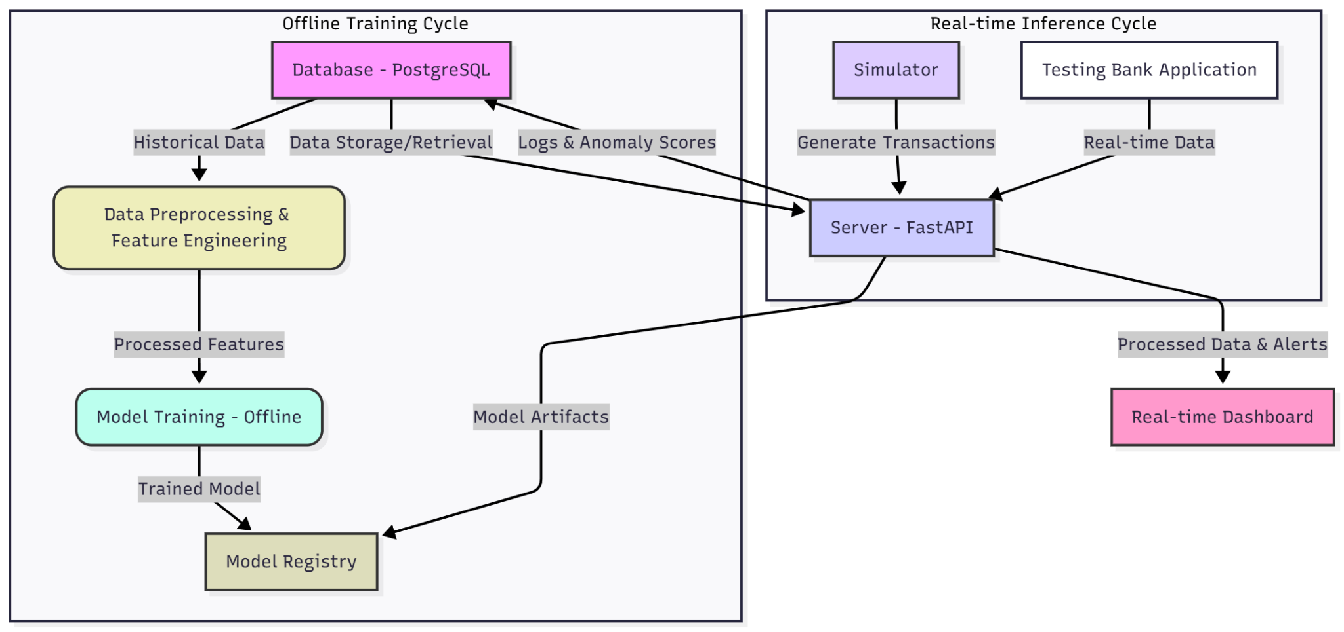
Figure 4.1: System Architecture of the Smart Fraud Detection System. The diagram illustrates the complete data flow, separating the Offline Training Cycle (data from PostgreSQL feeds the training pipeline) and the Real-Time Inference Cycle (FastAPI orchestrates prediction using models from the Model Registry and logs results to PostgreSQL

4.1 High-Level Architecture
The system follows a microservices-oriented architecture comprising the following components:
- FastAPI Server: Acts as the central controller, receiving requests and orchestrating model inference.
- PostgreSQL Database: Stores transaction logs, anomaly scores, and prediction history.
- Model Registry: A dedicated storage layer for versioned model artifacts (.pth, .json, .pkl).
- Dashboard: A Streamlit-based interface for real-time visualization.

4.2 Data Flow
- Ingestion: Raw transaction data is received via API.
- Preprocessing: Data is scaled using the persisted scaler.pkl.
- Feature Augmentation: The Autoencoder calculates the reconstruction error.
- Inference: XGBoost predicts the probability of fraud using the augmented feature set.
- Persistence: Results are logged asynchronously to the database.

5. Implementation Details

5.1 Technology Stack
- Language: Python 3.9+
- Deep Learning: PyTorch (for Autoencoder implementation).
- Machine Learning: XGBoost, Scikit-Learn.
- Backend: FastAPI, Uvicorn, SQLAlchemy (Async).
- Database: PostgreSQL (Dockerized).
- Visualization: Streamlit.

5.2 Training Optimization
Several techniques were employed to ensure training stability:
- Gradient Clipping: Applied to the Autoencoder to prevent exploding gradients.
- Learning Rate Scheduling: StepLR decays the learning rate by a factor of 0.5 every 10 epochs to fine-tune weights.
- Batch Processing: A batch size of 64 was selected to balance memory usage and gradient estimate accuracy.

6. Results and Evaluation

6.1 Evaluation Metrics
Given the cost of missed fraud, Recall is the prioritized metric, balanced against Precision to prevent alert fatigue.
- Confusion Matrix: Used to visualize TP, TN, FP, and FN.
- Precision:$\frac{TP}{TP+FP}$
- Recall (Sensitivity): $\frac{TP}{TP + FN}$
- F1-Score: Harmonic mean of Precision and Recall.

6.2 Performance Analysis
By augmenting features with the reconstruction error, the ensemble model demonstrates a higher separation capability between classes compared to a standalone XGBoost model. The Autoencoder successfully assigns high error scores to fraud cases (which it never saw during training), providing a strong signal to the classifier.

7. Conclusion and Future Work

7.1 Conclusion
This project successfully demonstrates the efficacy of combining unsupervised and supervised learning for fraud detection. The implemented system is not only accurate but also architecturally robust, capable of handling real-time requests via a modern API gateway. The ensemble approach effectively mitigates the class imbalance problem, leveraging the Autoencoder's sensitivity to outliers and XGBoost's classification power.

7.2 Future Enhancements
- Model Monitoring: Implementation of drift detection algorithms to trigger automated retraining.
- Explainability: Integration of SHAP (SHapley Additive exPlanations) values to provide investigators with reasons for specific fraud flags.
- Scalability: Deployment on Kubernetes with horizontal pod autoscaling to handle peak transaction loads.

8. References
[1] T. Chen and C. Guestrin, "XGBoost: A Scalable Tree Boosting System," 22nd ACM SIGKDD International Conference on Knowledge Discovery and Data Mining (KDD '16), 2016, arXiv:1603.02754.
[2] M. Sakurada and T. Yairi, "Anomaly detection using autoencoders with nonlinear dimensionality reduction," Proc. MLSDA Workshop, 2014, doi: 10.1145/2689746.2689747.
[3] H. Abbasimehr and H. Fanai, "A combined approach of the supervised autoencoder and XGBoost method for credit card fraud detection," Journal of Computational Science, 2022.
[4] D. P. Prabha and C. V. Priscilla, "A combined framework based on LSTM autoencoder and XGBoost with adaptive threshold classification for credit card fraud detection," 2024.

